

**A project Report on**

**DOMINO’S PIZZA WEBSITE USING AUTOMATION TOOL SELENIUM WEBDRIVER WITH JAVA.**

**By**

**Geeta Vaidya**

**Batch-EON (2021-5534)**

**Under the Guidance of,**

**Amruta Deore**

**(Technical Trainer)**

**EduBridge India Pvt. Ltd.**

**Introduction:**

This Project aims to do overall testing like functional testing, GUI testing on Dominos pizza website to check quality of application using selenium web driver. It helps to improve quality of website and saves time for manually doing this testing.

In this project our main focus is to test the Non Veg pizza Module. A Automation website is usually seeking to appeal to a broad audience and often has a Product of information to share with that audience. Finding the best design for your requirements means picking you battles .

**Software Requirements:**

Operating System: Windows 7

Browser: Latest version of Google Chrome

Platform: Eclipse IDE

Automation Tool and Language: Selenium WebDriver, Java

Files: JDK, Selenium Jar files, Common IO file

**NON-VEG PIZZA MODULE**

**TC01:** Launch the browser and Domino’s pizza website

**Selenium WebDriver Test Script:**

System.*setProperty*("webdriver.chrome.driver", "C:\\seleniumwebdriver\\ChromeDrivers\\chromedriver.exe");

WebDriver driver =**new** ChromeDriver();

driver.manage().timeouts().implicitlyWait(3,TimeUnit.***SECONDS***);

driver.manage().window().maximize();

driver.get("https://pizzaonline.dominos.co.in/menu?categoryId=3");

System.***out***.println(" Open Domino's website");

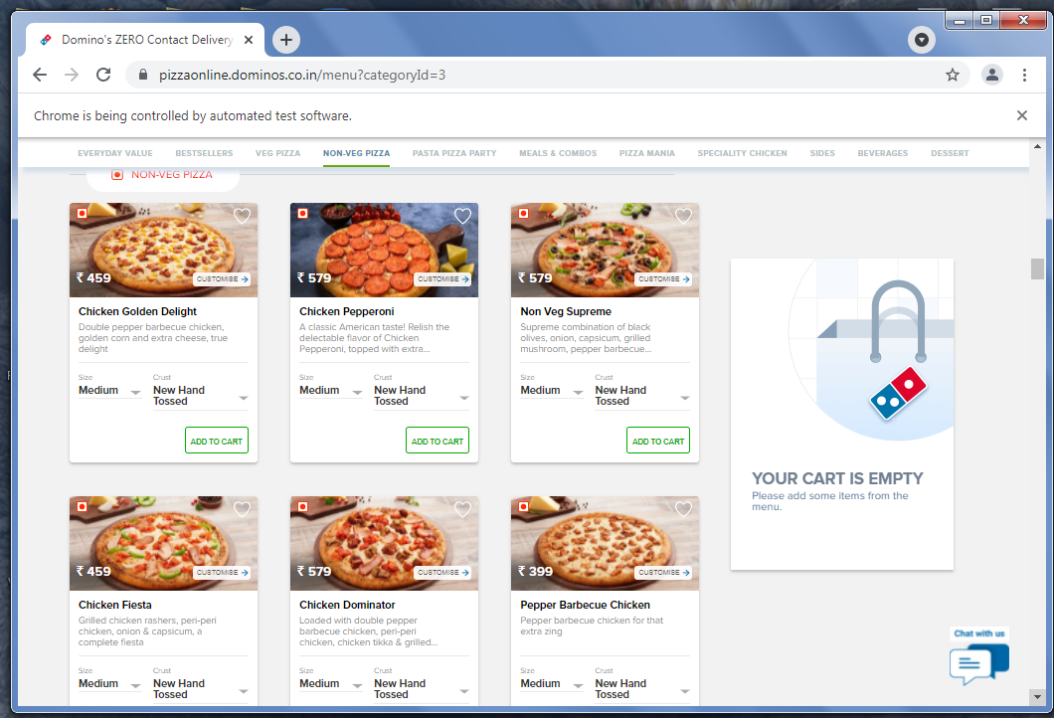

**TC02:** To select the Non-veg pizza from menu.

**Selenium WebDriver Test Script:**

driver.findElement(By.*xpath*("//body/div[@id='__next']/div[1]/div[1]/div[1]/div[2]/

div[2]/div[2]/div[1]/div[6]/div[1]/div[1]/div[1]/div[1]")).click(); System.***out***.println("Nonveg Pizza menu window is display");

**TC03:** To select Chicken Golden Delight Pizza from veg pizza menu.

**Selenium WebDriver Test Script:**

driver.findElement(By.*xpath*("//body/div[@id='__next']/div[1]/div[1]/div[1]/div[2]/div[2]/div[2]/div[1]/div[6]/div[1]/div[1]/div[1]/div[1]/div[1]/div[1]/div[1]/img[1]")).click();

System.***out***.println("Chicken Golden Delight pizza is display");

**TC04:** To verify size of the pizza selected.

**Selenium WebDriver Test Script:**

driver.findElement(By.*xpath*("//span[contains(text(),'Serves 2')]")).click();

js.executeScript("window.scrollBy(0,550)");

System.***out***.println("Select Size menu is display");

**TC05:** To verify the crust added from the list.

**Selenium WebDriver Test Script:**

driver.findElement(By.*xpath*("//body/div[@id='__next']/div[1]/div[1]/div[1]/div[2]/div[1]/div[1]/div[3]/div[1]/div[1]/div[3]/div[1]/div[1]/div[2]/div[1]/div[1]/div[1]/div[1]/div[2]/ul[1]/li[3]/div[1]/div[1]/span[1]")).click();

js.executeScript("window.scrollBy(0,1200)");

System.***out***.println("Select Crust menu is display");

**TC06:** To verify the veg topping and extra cheese added from the list.

**Selenium WebDriver Test Script:**

WebElement add_cheese = driver.findElement(By.*xpath*("//*[@id=\"__next\"]/div/div/div[1]/div[2]/div[1]/div/div[3]/div/div/div[3]/div[2]/div"));

js.executeScript("arguments[0].click()",add_cheese);

System.***out***.println("cheese added");

WebElement add_mashroom = driver.findElement(By.*xpath*("//*[@id=\"__next\"]/div/div/div[1]/div[2]/div[1]/div/div[3]/div/div/div[3]/div[3]/div[2]/div[2]/div/div/div/div[2]/ul/li[1]/div/div[2]"));

js.executeScript("arguments[0].click()",add_mashroom);

System.***out***.println("mashroom added");

WebElement add_onion = driver.findElement(By.*xpath*("//*[@id=\"__next\"]/div/div/div[1]/div[2]/div[1]/div/div[3]/div/div/div[3]/div[3]/div[2]/div[2]/div/div/div/div[2]/ul/li[2]"));

add_onion.click();

System.***out***.println("onion added");

WebElement add_cpsicm = driver.findElement(By.*xpath*("//*[@id=\"__next\"]/div/div/div[1]/div[2]/div[1]/div/div[3]/div/div/div[3]/div[3]/div[2]/div[2]/div/div/div/div[2]/ul/li[3]"));

add_cpsicm.click();

System.***out***.println("capcicm added");

**TC07:** To verify the non-veg toppings added from the list

**Selenium WebDriver Test Script:**

driver.findElement(By.*xpath*("//body/div[@id='__next']/div[1]/div[1]/div[1]/div[2]/div[1]/div[1]/div[3]/div[1]/div[1]/div[3]/div[3]/div[3]/div[2]/div[1]/div[1]/div[1]/div[2]/ul[1]/li[1]/div[1]/div[1]/img[1]")).click(); js.executeScript("window.scrollBy(0,1350)");

System.***out***.println("Pepper Barbecue Chicken is selected");

driver.findElement(By.*xpath*("//body/div[@id='__next']/div[1]/div[1]/div[1]/div[2]/div[1]/div[1]/div[3]/div[1]/div[1]/div[3]/div[3]/div[3]/div[2]/div[1]/div[1]/div[1]/div[2]/ul[1]/li[2]/div[1]/div[1]/img[1]")).click();

System.***out***.println("PeriPeriChicken is selected");

driver.findElement(By.*xpath*("//body/div[@id='__next']/div[1]/div[1]/div[1]/div[2]/div[1]/div[1]/div[3]/div[1]/div[1]/div[3]/div[3]/div[3]/div[2]/div[1]/div[1]/div[1]/div[2]/ul[1]/li[3]/div[1]/div[1]/img[1]")).click();

System.***out***.println("Grilled Chicken Rasher is selected");

**TC08:** To verify the functionality of add to cart.

**Selenium WebDriver Test Script:**

driver.findElement(By.*xpath*("//*[@id=\"__next\"]/div/div/div[1]/div[2]/div[1]/div/div[3]/div/div/div[4]/div/div[2]/button/span")).click();;

System.***out***.println("added to cart");

**TC09:** To verify the functionality of increase and decrease quantity.

**Selenium WebDriver Test Script:**

driver.findElement(By.*xpath*("//*[@id=\"__next\"]/div/div/div[1]/div[2]/div[2]/div[2]/div[2]/div/div/div[1]/div/div/div/div[2]/div/div/div[2]")).click();;

System.***out***.println("quantity increased");

**TC10:** To verify the functionality of checkout button.

**Selenium WebDriver Test Script:**

driver.findElement(By.*xpath*("//*[@id=\"__next\"]/div/div/div[1]/div[2]/div[2]/div[2]/div[2]/div/div/div[2]/div[2]/button/span")).click();;

System.***out***.println("checkout");

**TC11:** To verify the functionality of add location button.

**Selenium WebDriver Test Script:**

driver.findElement(By.*xpath*("//*[@id=\"__next\"]/div/div[1]/div[2]/div[3]/div[2]/div/div[1]/div/div[1]/div[2]/div")).click();;

System.***out***.println("clicked on add location");

**TC12:** To verify the address is entering in address field

**Selenium WebDriver Test Script:**

driver.findElement(By.*xpath*("/html/body/div[1]/div/div[1]/div[2]/div[3]/div[2]/div/div[2]/div/div[3]/div/div[1]/div[2]/div/div[1]/input")).sendKeys("navi mumbai");

driver.findElement(By.*xpath*("/html/body/div[1]/div/div[1]/div[2]/div[3]/div[2]/div/div[2]/div/div[3]/div/div[1]/div[2]/div[2]/div/ul/li[1]/div[2]/span[1]")).click();

driver.findElement(By.*xpath*("/html/body/div[1]/div/div[1]/div[2]/div[3]/div[2]/div/div[2]/div/div[3]/div/div[1]/div[2]/div/div[2]/div/input")).sendKeys("Koparkhairane");

driver.findElement(By.*xpath*("//*[@id=\"__next\"]/div/div[1]/div[2]/div[3]/div[2]/div/div[2]/div/div[3]/div/div[1]/div[2]/div[2]/div/ul/li[4]/div[2]")).click();

System.***out***.println("address selected");

**TC13:** To verify the functionality of place order.

**Selenium WebDriver Test Script:**

driver.findElement(By.*xpath*("//*[@id=\"__next\"]/div/div[1]/div[2]/div[3]/div[2]/div/div[6]/div/div/div[7]/button/span")).click();

System.***out***.println("order placed");

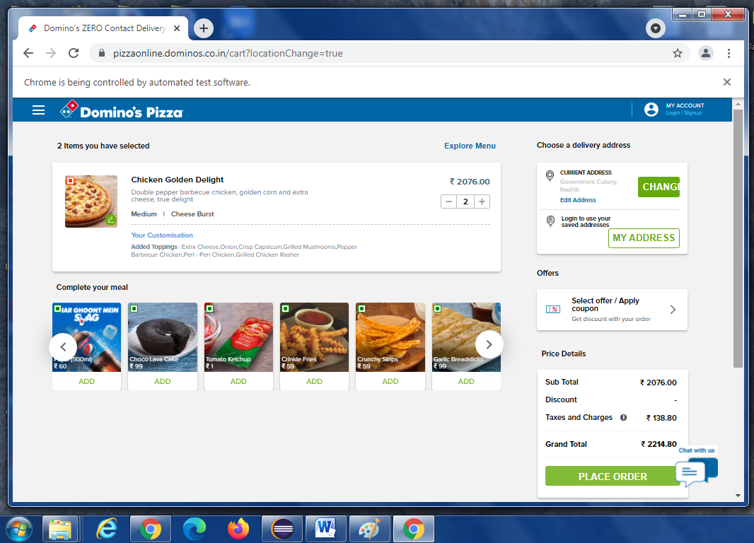

**TC14:** To verify that browser is able to close.

**Selenium WebDriver Test Script:**

driver.close();